**3.STATIC SYNCHRONOUS COMPENSATOR**

**3.1. Introduction**

The STATCOM is a solid-state-based power converter version of the SVC. Operating as a shunt-connected SVC, its capacitive or inductive output currents can be controlled independently from its terminal AC bus voltage. Because of the fast-switching characteristic of power converters, STATCOM provides much faster response as compared to the SVC. In addition, in the event of a rapid change in system voltage, the capacitor voltage does not change instantaneously therefore STATCOM effectively reacts for the desired responses. For example, if the system voltage drops for any reason, there is a tendency for STATCOM to inject capacitive power to support the dipped voltages.

STATCOM is capable of high dynamic performance and its compensation does not depend on the common coupling voltage. Therefore, STATCOM is very effective during the power system disturbances.

Moreover, much research confirms several advantages of STATCOM. These advantages compared to other shunt compensators include

• Size, weight, and cost reduction

• Equality of lagging and leading output

• Precise and continuous reactive power control with fast response

• Possible active harmonic filter capability

This chapter describes the structure, basic operating principle and characteristics of STATCOM. In addition, the concept of voltage source converters and the corresponding control techniques are illustrated. The main purpose of the coupling inductors is to filter out the current harmonic components that are generated mainly by the pulsating output voltage of the power converters.

In this section, 3.2discuss the structure of STATCOM, 3.3 discuss the control of STATCOM, 3.3.1discuss the two modes of operation, 3.3.2 discuss the current controlled STATCOM, 3.3.3 discuss the voltage controlled STATCOM, 3.4 discuss the basic operating principles of STATCOM, 3.8 discuss the series devices, 3.6 discuss the functional requirements of STATCOM, 3.7 discuss the STATCOM characteristics, 3.5 discuss the characteristics of STATCOM.

**3.2. Structure Of STATCOM**

Basically, STATCOM is comprised of three main parts a Voltage Source Converter (VSC), a step-up coupling transformer, and a controller. In a very-high-voltage system, the leakage inductances of the step-up power transformers can function as coupling reactors. The main purpose of the coupling inductors is to filter out the current harmonic components that are generated mainly by the pulsating output voltage of the power converters.

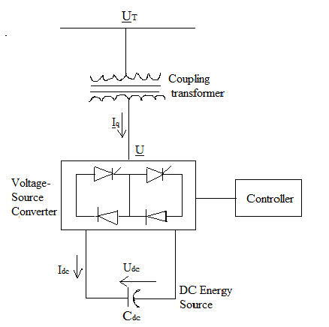

**Fig.3.1. Reactive power generation by a STATCOM**

**3.3. Control Of STATCOM**

The controller of a STATCOM operates the converter in a particular way that the phase angle between the converter voltage and the transmission line voltage is dynamically adjusted and synchronized so that the STATCOM generates or absorbs desired VAR at the point of coupling connection.

Figure 3.1 shows a simplified diagram of the STATCOM with a converter voltage source and a tie reactance, connected to a system with a voltage source, and a Thevenin reactance.

3.3.1. Two Modes Of Operation

There are two modes of operation for a STATCOM, inductive mode and the capacitive mode. The STATCOM regards an inductive reactance connected at its terminal when the converter voltage is higher than the transmission line voltage. Hence, from the system’s point of view, it regards the STATCOM as a capacitive reactance and the STATCOM is considered to be operating in a capacitive mode. Similarly, when the system voltage is higher than the converter voltage, the system regards an inductive reactance connected at its terminal. Hence, the STATCOM regards the system as a capacitive reactance and the STATCOM is considered to be operating in an inductive mode.



**Fig.3.2. STATCOM operating in inductive or capacitive modes**

In other words, looking at the phasor diagrams, when the reactive current component of the STATCOM, leads by 90º, it is in inductive mode and when it lags by 90º, it is in capacitive mode.

This dual mode capability enables the STATCOM to provide inductive compensation as well as capacitive compensation to a system. Inductive compensation of the STATCOM makes it unique. This inductive compensation is to provide inductive reactance when overcompensation due to capacitors banks occurs.

This happens during the night, when a typical inductive load is about 20% of the full load, and the capacitor banks along the transmission line provide with excessive capacitive reactance due to the lower load. Basically the control system for a STATCOM consists of a current control and a voltage control.

3.3.2. Current Controlled STATCOM



**Fig.3.3. Current controlled block diagram of STATCOM**

The fig 3.3 shows the reactive current control block diagram of the STATCOM. An instantaneous three-phase set of line voltages Vl, at BUS 1 is used to calculate the reference angle θ, which is phase locked to the phase of a the line voltage Vla. An instantaneous three-phase set of measured converter currents il, is decomposed into its real or direct component, I1d, and reactive or quadrature component, I1q, respectively. The quadrature component is compared with the desired reference value I1qand the error is passed through an error amplifier which produces a relative angle α, of the converter voltage with respect to the transmission line voltage. The phase angle θ1, of the converter voltage is calculated by adding the relative angle α, of the converter voltage and the phase-lock-loop angle θ. The reference quadrature component I1q, of the converter current is defined to be either positiveif the STATCOM is emulating an inductive reactance or negativeif it is emulating a capacitive reactance.

The DC capacitor voltage, VDC, is dynamically adjusted in relation with the converter voltage. The control scheme described above shows the implementation of the inner current control loop which regulates the reactive current flow through the STATCOM regardless of the line voltage.

3.3.3. Voltage Controlled STATCOM

In regulating the line voltage, an outer voltage control loop must be implemented. The outer voltage control loop would automatically determine the reference reactive current for the inner current control loop which, in turn, will regulate the line voltage.



**Fig.3.4. Voltage controlled block diagram of STATCOM**

The fig 3.4 shows a voltage control block diagram of the STATCOM. An instantaneous three-phase set of measured line voltages v1, at BUS 1 is decomposed into its real or direct component V1d, and reactive or quadrature component V1q, is compared with the desired reference value V1, and the error is passed through an error amplifier which produces the reference current I1q, for the inner current control loop. The droop factor Kdrop, is defined as the allowable voltage error at the rated reactive current flow through the STATCOM.

**3.4. Basic Operating Principles Of STATCOM**

The STATCOM is connected to the power system at a PCC point of common coupling, through a step-up coupling transformer, where the voltage-quality problem is a concern. The PCC is also known as the terminal for which the terminal voltage is UT. All required voltages and currents are measured and are fed into the controller to be compared with the commands.

The controller then performs feedback control and outputs a set of switching signals to drive the main semiconductor switches of the power converter accordingly to either increase the voltage or to decrease it accordingly. A STATCOM is a controlled reactive-power source. It provides voltage support by generating or absorbing reactive power at the point of common coupling without the need of large external reactors or capacitor banks. Using the controller, the VSC and the coupling transformer, the STATCOM operation is illustrated in Figure below.

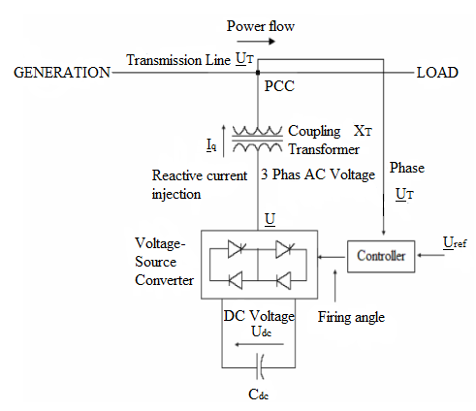

**Fig.3.5.STATCOM operation in a power system**

The charged capacitor Cdc provides a DC voltage, Udc to the converter, which produces a set of controllable three-phase output voltages, U in synchronism with the AC system. The synchronism of the three-phase output voltage with the transmission line voltage has to be performed by an external controller. The amount of desired voltage across STATCOM, which is the voltage reference, Uref, is set manually to the controller. The voltage control is thereby to match UT with Uref which has been elaborated.

This matching of voltages is done by varying the amplitude of the output voltage U, which is done by the firing angle set by the controller. The controller thus sets UT equivalent to the Uref. The reactive power exchange between the converter and the AC system can also be controlled. This reactive power exchange is the reactive current injected by the STATCOM, which is the current from the capacitor produced by absorbing real power from the AC system.

Iq=(Ut-Ueq)/Xeq … (3.1)

Where,

Iq is the reactive current injected by the STATCOM

UT is the STATCOM terminal voltage

Ueq is the equivalent Thevenins voltage seen by the STATCOM

Xeq is the equivalent Thevenins reactance of the power system seen by the STATCOM

If the amplitude of the output voltage U is increased above that of the AC system voltage, UT, a leading current is produced, i.e. the STATCOM is seen as a conductor by the AC system and reactive power is generated. Decreasing the amplitude of the output voltage below that of the AC system, a lagging current results and the STATCOM is seen as an inductor. In this case reactive power is absorbed. If the amplitudes are equal no power exchange takes place.

A practical converter is not lossless. In the case of the DC capacitor, the energy stored in this capacitor would be consumed by the internal losses of the converter.

**Fig.3.6. Phasor diagrams for STATCOM applications**

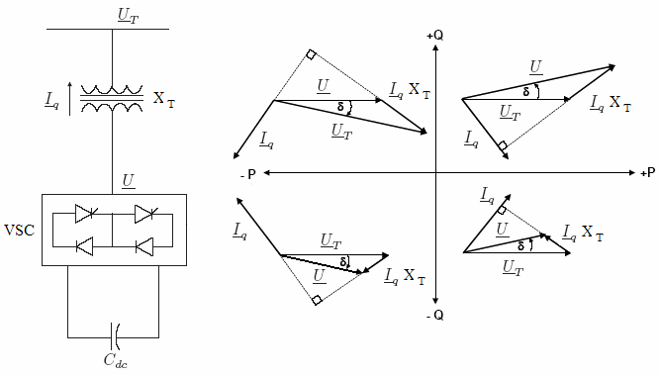

The mechanism of phase angle adjustment, angle δ, can also be used to control the reactive power generation or absorption by increasing or decreasing the capacitor voltage Udc, with reference the output voltage U.

Instead of a capacitor a battery can also be used as DC energy. In this case the converter can control both reactive and active power exchange with the AC system. The capability of controlling active as well as reactive power exchange is a significant feature which can be used effectively in applications requiring power oscillation damping, to level peak power demand, and to provide uninterrupted power for critical load.

**3.5. Characteristics Of STATCOM**

The derivation of the formula for the transmitted active power employs considerable calculations. Applying Kirchhoff’s laws the following equations can be written

I2 … (3.2)



**Fig.3.7. Two machine system with STATCOM**

By equaling right-hand terms of the above formulas, a formula for the current I1 is obtained as

$I_{1}=\frac{U_{1}-U_{2}}{j{(X_{2}+X_{2})}_{1}}+I_{Q}\frac{X_{2}}{{(X}_{1}{+X}_{2})}$… (3.3)

${\underline{U}}_{T}={\underline{U}}_{1}-j{\underline{I}}_{1}X_{1}={\underline{U}}_{1}-\frac{\left({\underline{U}}_{1}-{\underline{U}}_{2}\right)X_{1}}{\left(X_{1}+X_{2}\right)}-j{\underline{I}}_{q}∙\frac{X_{1}+X_{2}}{\left(X_{1}+X_{2}\right)}$… (3.4)

${\underline{U}}_{T}={\underline{U}}_{R}-j{\underline{I}}_{q}∙\frac{X_{1}X_{2}}{\left(X_{1}+X_{2}\right)}$… (3.5)

${\underline{I}}_{q}=jI_{q}∙\frac{{\underline{U}}_{R}}{U_{R}}$… (3.6)

${\underline{U}}_{T}={\underline{U}}_{R}+I_{q}\frac{{\underline{U}}_{R}}{U_{R}}∙\frac{X_{1}X_{2}}{\left(X_{1}+X_{2}\right)}={\underline{U}}_{R}\left(1+\frac{I_{q}}{U_{R}}∙\frac{X_{1}X_{2}}{\left(X_{1}+X_{2}\right)}\right)$… (3.7)

Applying the sine law to the diagram in Figure below the following two equations result

$\frac{\sin{β}}{U_{2}}=\frac{\sin{δ}}{\left|{\underline{U}}_{1}-{\underline{U}}_{2}\right|}$… (3.8)

$\frac{\sin{α}}{\left|{\underline{U}}_{1}+{\underline{U}}_{2}\right|\frac{X_{1}}{\left(X_{1}+X_{2}\right)}}=\frac{\sin{β}}{U_{R}}$… (3.9)

From which the formula for sin α is derived as

$\sin{α=\frac{U_{2}\sin{δX_{1}}}{U_{R}\left(X_{1}+X_{2}\right)}}$… (3.10)

The formula for the transmitted active power can be given as

$P=P_{1}=P_{2}=\frac{U_{T}U_{1}}{X_{1}}\sin{α=\frac{U_{1}U_{2}\sin{δ}}{\left(X_{1}+X_{2}\right)}}∙\frac{U_{T}}{U_{R}}$… (3.11)

To dispose of the term UR the cosine law is applied to the diagram in Figure above Therefore,

$U_{R}=\left|{\underline{U}}_{R}\right|=\left|\frac{{\underline{U}}_{1}X_{2}+U_{2}X_{1}}{\left(X_{1}+X_{2}\right)}\right|\frac{\sqrt{{U^{2}}_{1}{X^{2}}_{2}+{U^{2}}_{2}{X^{2}}_{1}+2U_{1}U_{2}X_{1}X_{2}\cos{δ}}}{\left(X_{1}+X_{2}\right)}$… (3.12)

$P=\frac{U_{1}U_{2}\sin{δ}}{\left(X_{1}+X_{2}\right)}\left(1+\frac{I_{q}}{U_{R}}∙\frac{X_{1}X_{2}}{\left(X_{1}+X_{2}\right)}\right)$… (3.13)



**Fig.3.8. Transmitted power versus transmission angle characteristic of a STATCOM**

With these concepts of STATCOM, it is thus important to utilize these principles in accommodating shunt compensation to any system.

**3.6. Functional Requirements Of STATCOM**

The main functional requirements of the STATCOM in this thesis are to provide shunt compensation, operating in capacitive mode only, in terms of the following Voltage stability control in a power system, as to compensate the loss voltage along transmission. This compensation of voltage has to be in synchronism with the AC system regardless of disturbances or change of load.

**.** Transient stability during disturbances in a system or a change of load. Direct voltage support to maintain sufficient line voltage for facilitating increased reactive power flow under heavy loads and for preventing voltage instability

• Transient stability during disturbances in a system or a change of load. Direct voltage support to maintain sufficient line voltage for facilitating increased reactive power flow under heavy loads and for preventing voltage instability

• Reactive power injection by STATCOM into the system. The design phase and implementation phase would refer to the theoretical background of STATCOM in providing the requirements.

**3.7. STATCOM Characteristics**

The advantage of a STATCOM is that the reactive power provision is independent from the actual voltage on the connection point. This can be seen in the diagram for the maximum currents being independent of the voltage in comparison to the SVC. This means, that even during most severe contingencies, the STATCOM keeps its full capability.

In the distributed energy sector the usage of voltage source converters for grid interconnection is common practice today. The next step in STATCOM development is the combination with energy storages on the dc-side. The performance for power quality and balanced network operation can be improved much more with the combination of active and reactive power.

The capability of controlling active as well as reactive power exchange is a significant feature which can be used effectively in applications requiring power oscillation damping, to level peak power demand, and to provide uninterrupted power for critical load.



**Fig.3.9. STATCOM structure and voltage / current characteristic**

STATCOM’s are based on voltage sourced converter VSC topology and utilize either gate-turn-off thyristors or isolated gate bipolar transistors devices. The STATCOM is a very fast acting, electronic equivalent of a synchronous condenser. If the STATCOM voltage, vs., which is proportional to the dc bus voltage Vc is larger than bus voltage, as, then leading or capacitive VAR’s are produced. If Vsis smaller than lagging or inductive VAR’s are produced.

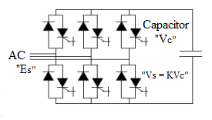

**Fig.3.10. pulses STATCOM**

The three phases STATCOM makes use of the fact that on a three phase, fundamental frequency, steady state basis, and the instantaneous power entering a purely reactive device must be zero. The reactive power in each phase is supplied by circulating the instantaneous real power between the phases. This is achieved by firing the go to diode switches in a manner that maintains the phase difference between the ac bus voltage as and the STATCOM generated voltage vs. ideally it is possible to construct a device based on circulating instantaneous power which has no energy storage device.

A practical STATCOM requires some amount of energy storage to accommodate harmonic power and ac system unbalances, when the instantaneous real power is non-zero. The maximum energy storage required for the STATCOM is much less than for a TCR or TSC type of svc compensator of comparable rating.

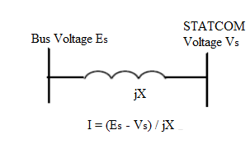

**Fig.3.11. STATCOM equivalent circuit**

Several different control techniques can be used for the firing control of the STATCOM. Fundamental switching of the go to diode once per cycle can be used. This approach will minimize switching losses, but will generally utilize more complex transformer topologies. As an alternative, pulse width modulated techniques, which turn on and off the go to or IGBT switch more than once per cycle, can be used. This approach allows for simpler transformer topologies at the expense of higher switching losses.

The 6 pulse STATCOM using fundamental switching will of course produce the 6 (n-1) harmonics. There are a variety of methods to decrease the harmonics.

These methods include the basic 12 pulse configuration with parallel star or delta transformer connections, a complete elimination of 5th and 7th harmonic current using series connection of star or star and star or delta transformers and a quasi 12 pulse method with a single star-star transformer, and two secondary windings, using control of firing angle to produce a 300 phase shift between the two 6 pulse bridges. This method can be extended to produce a 24 pulse and a 48 pulse STATCOM, thus eliminating harmonics even further. Another possible approach for harmonic cancellation is a multi-level configuration which allows for more than one switching element per level and therefore more than one switching in each bridge arm. The ac voltage derived has a staircase effect, dependent on the number of levels. This staircase voltage can be controlled to eliminate harmonics.

**3.8. Series Devices**

Series devices have been further developed from fixed or mechanically switched compensations to the Thyristor Controlled Series Compensation even voltage source converter based devices.

The main applications of series devices

• Reduction of series voltage decline in magnitude and angle over a

Power line.

• Reduction of voltage fluctuations within defined limits during

changing power transmissions.

• Improvement of system damping res damping of oscillations.

• Limitation of short circuit currents in networks or substations.

**3.9. Summary**

STATCOM is capable of high dynamic performance and its compensation does not depend on the common coupling voltage. Therefore, STATCOM is very effective during the power system disturbances.

The STATCOM is a solid-state-based power converter version of the SVC. Operating as a shunt-connected SVC, its capacitive or inductive output currents can be controlled independently from its terminal AC bus voltage. Because of the fast-switching characteristic of power converters, STATCOM provides much faster response as compared to the SVC. In addition, in the event of a rapid change in system voltage, the capacitor voltage does not change instantaneously therefore STATCOM effectively reacts for the desired responses.